DIPLÔME DE COMPTABILITÉ ET DE GESTION

UE 12 – ANGLAIS DES AFFAIRES

SESSION 2024

Durée de l’épreuve : 3 h 00 – Coefficient : 1

Aucun matériel (agenda, calculatrice, traductrice, ni dictionnaire.) n’est autorisé.

Dès que le sujet vous est remis, assurez-vous qu’il est complet.
Le sujet comporte 6 pages numérotées de 1 / 6 à 6 / 6.

DOCUMENT 1

Companies use AI to monitor workers—45% of employees say it has a negative effect on their mental health
As companies implement return-to-office plans, employers are increasingly interested in utilizing artificial intelligence, not to replace workers, but to watch them. Between March 2020 and June 2023, demand for employee surveillance software grew 54%, according to research from Top10VPN, a virtual private network comparison site. And employees are noticing. Fifty-one percent say they are aware that their employer uses technology to monitor them while they are working, according to data from the American Psychological Association. Knowing they are being watched has had negative psychological effects. Almost one-third, 32%, of employees who know their bosses are using technology to monitor them reported their mental health as fair or poor, according to data from the APA. [...] Employers are using technologies that track when workers are logging on and off, who they are communicating with and what they are saying. One software, Traqq, will “detect and report the apps and websites a user spends more than 10 seconds on,” according to its website. Another software called Time Doctor allows “ethical video screen recording” so employers can see if workers are “actually working on their task or watching a Netflix show instead,” according to its site.
[...] This will undoubtedly result in strained relationships between bosses and those they manage, Leslie Hammer, a professor at Oregon Health & Science University and co-director of the Oregon Healthy Workforce Center, told the APA. “When employees feel they are not cared for or trusted by their employers, they are likely to have lower levels of commitment to the organization and perceive lower levels of psychological safety and higher levels of stress, all negatively affecting the relationship between employees and their employers, and specifically their managers and supervisors,” Hammer said. Some employees did see a few potentially positive outcomes to AI monitoring, according to data from the Pew Research Center. Almost half, 49%, say workplace security would improve, and 46% said inappropriate behavior in the workplace would likely decrease. [...]
CNBC, Aditi Shrikant, September 8 2023

DOCUMENT 2

Use of AI could create a four-day week for almost one-third of workers
Artificial intelligence could enable millions of workers to move to a four-day week by 2033, according to a new study focusing on British and American workforces. The report from the thinktank Autonomy found that projected productivity gains from the introduction of AI could reduce the working week from 40 to 32 hours for 28% of the workforce – 8.8 million people in Britain and 35 million in the US – while maintaining pay and performance. The study says this could be achieved by bringing large language models (LLMs), such as ChatGPT, into workplaces to augment workers’ roles and create more free time. According to Autonomy, such a policy could also help to avoid mass unemployment and reduce widespread mental and physical illnesses. Will Stronge, the director of research at Autonomy, said: “Too many studies of AI, large language models, and so on, solely focus on either profitability or a jobs apocalypse. This study tries to show that when the technology is deployed to its full potential, but the purpose of the technology is shifted, it can not only improve work practices, but also improve work-life balance.” [...] Congressman Mark Takano, who has introduced a 32-hour work week bill to the US Congress, said: “Fundamental changes are coming to our workforce due to AI and automation. It will take government action to ensure gains in efficiency are felt by all workers, regardless of industry or skill level.” [...] Stronge said: “What I think would be really impressive would be a robust AI industrial strategy, with automation hubs where trade unions, industry and experts in this tech get together to say: ‘We’re going to boost productivity, and this is also going to be something which delivers for the workers.’”
The Guardian, Philippa Kelly, 20 Nov 2023

DOCUMENT 3

How the AI revolution is different: It threatens white-collar workers
The emergence of artificial intelligence like ChatGPT has aroused fears of these tools replacing people in a range of professions, from coders to truck drivers. Although such concerns tend to ignore technology's potential to create jobs, new forms of AI do pose a risk to some workers, new research from Indeed suggests: white-collar workers. "Surprisingly enough, knowledge workers are facing the highest level of exposure here, which is quite different with what we've seen with other revolutions," Gudell said. "With automation, often it was manual labor that was replaced," Svenja Gudell, chief economist at the job-search platform, told CBS MoneyWatch. Unlike previous cycles of technical innovation, in-person, often low-wage jobs that rely heavily on humans being physically present are likely to be the the most resilient to encroaching AI, she added. "Driving cars still currently takes a person. Or child care. We probably wouldn't give our kids over to the robots quite yet," she said. [...] Among the openings currently on Indeed, software and coding jobs are the most exposed to replacement by AI, the firm found in a its analysis. That's because so-called generative AI was determined to be adept at performing 95% of the skills these jobs require. In addition to software development, information technology, mathematics, information design, legal and accounting positions are also among the more exposed professions. By contrast, truck and taxi driver jobs are least exposed to AI, which could only adequately perform about 30% of the necessary skills, according to Indeed. Other jobs that are relatively insulated against AI include cleaning and sanitation as well as beauty and wellness jobs, in part because they are least likely to be performed remotely. Another key takeway, according to Indeed: the more suitable a job is to remote work, the higher its potential exposure is to generative AI-driven change.
CBS MoneyWatch, Megan Cerullo September 21 2023

DOCUMENT 4 “AI taking over?”
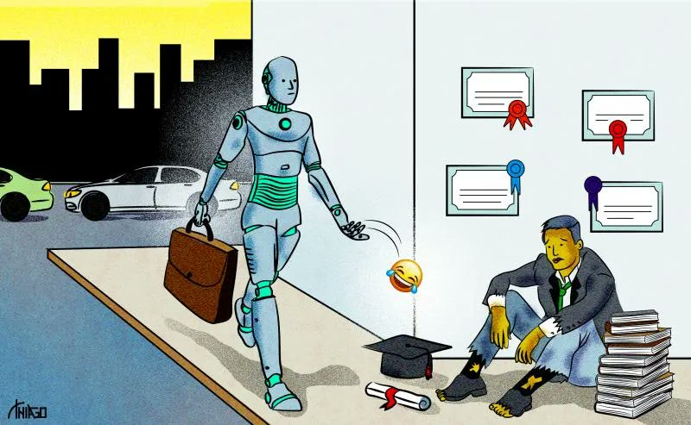

Source : cartoonomovement.com, Thiago Lucas, 24 April 2023.

Le dossier comporte 4 documents :

DOCUMENT 1 : un extrait d’article publié par CNBC le 8 septembre 2023 et intitulé «Companies use AI to monitor workers—45% of employees say it has a negative effect on their mental health.»

DOCUMENT 2 : un extrait d’article publié par The Guardian le 20 novembre 2023 et intitulé «Use of AI could create a four-day week for almost one-third of workers»

DOCUMENT 3 : un extrait d’article publié par CBS MoneyWatch le 21 septembre 2023 et intitulé «How the AI revolution is different: It threatens white-collar workers»
DOCUMENT 4 : un dessin humoristique de Thiago Lucas publié le 24 avril 2023 sur cartoonmovement.com

- COMPRÉHENSION (10 points)
En vous appuyant sur les quatre documents fournis, vous rédigerez en français une note de synthèse qui rendra compte de la problématique de ce dossier.
Vous indiquerez le nombre de mots utilisés. 250 mots (+/- 10 %)

- EXPRESSION EN LANGUE ANGLAISE (10 points)
- Comment on document 4.
Vous indiquerez le nombre de mots utilisés (150 mots +/- 10 %).
2. Write an email.
Vous êtes Alex Smith, P.D.G. de la multinationale Smith Inc.
Vous écrivez un email à John ou Jane Carter, directeur/directrice des Ressources Humaines pour lui faire part de votre volonté de promouvoir l’utilisation d’outils d’intelligence artificielle au sein de votre entreprise.
Détaillez les nombreux avantages que l’IA pourrait offrir à votre entreprise et anticipez les potentielles craintes de vos collaborateurs. Rassurez-les sur ces dernières. Formules et présentation d’usage.
150 mots, +/-10 %.
Vous indiquerez le nombre de mots utilisés.

